Ansible-02

1) Watch ansible-02 video and write down notes.

Completed.

2) Install httpd using ansible playbook, use handlers,notifiers.

---

- hosts: all

become: yes

tasks:

- name: Install Apache

apt: name=apache2 state=latest

- name: copy index.html

copy: src=index.html dest=/var/www/html

notify: restart apache2

handlers:

- name: restart apache2

service: name=apache2 state=restarted

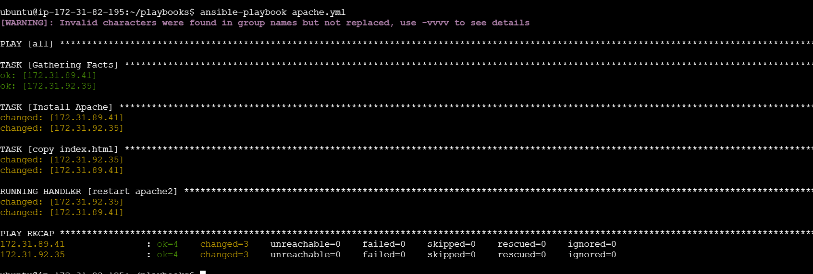

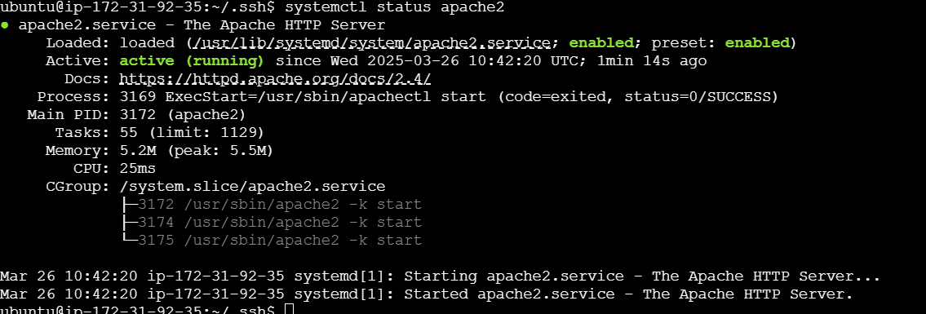

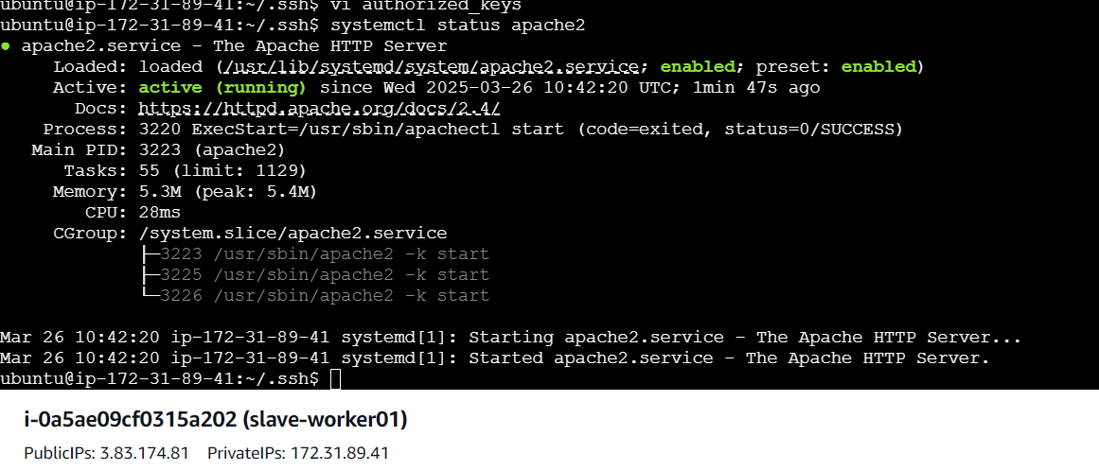

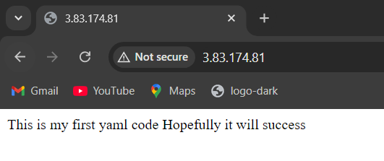

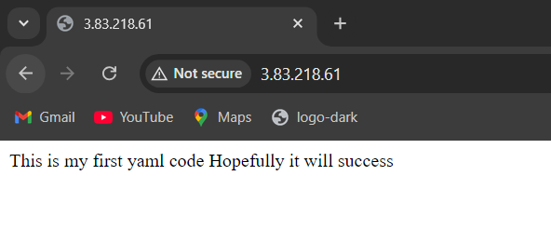

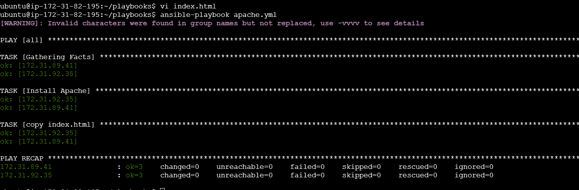

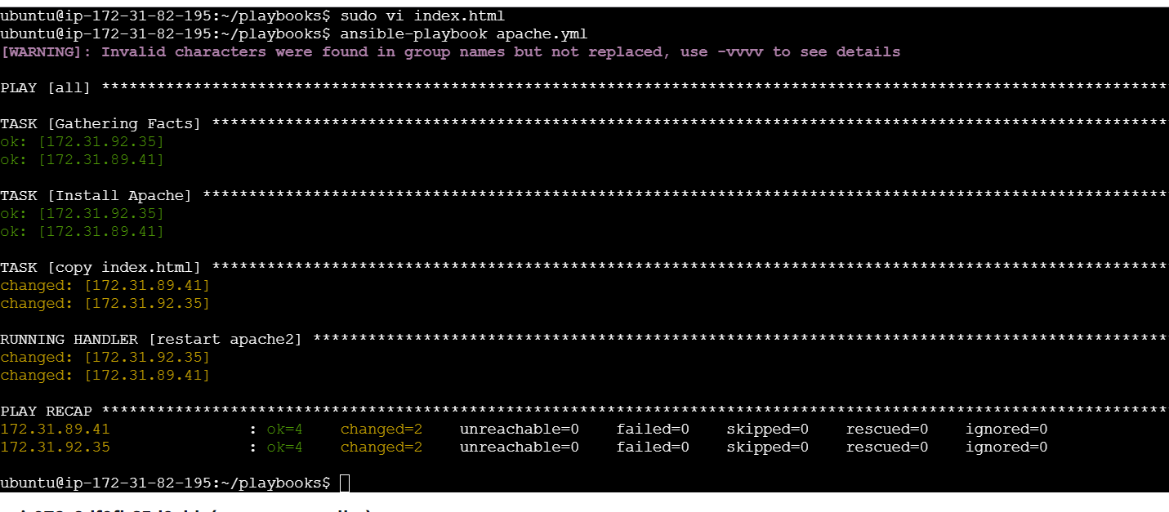

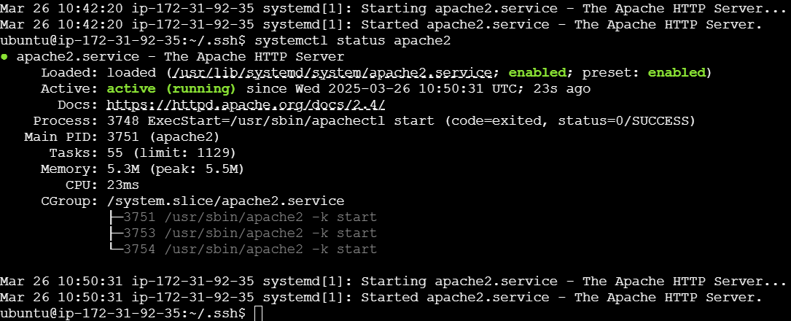

3) Write an ansible playbook to install apache tomcat.

---

- hosts: all

become: yes

tasks:

- name: Install Java

apt:

name: default-jdk

state: present

- name: Download Tomcat

get_url:

url: "https://archive.apache.org/dist/tomcat/tomcat-9/v9.0.80/bin/apache-tomcat-9.0.80.tar.gz"

dest: /tmp/

- name: Extract Tomcat

unarchive:

src: /tmp/apache-tomcat-9.0.80.tar.gz

dest: /opt/

remote_src: yes

- name: Start Tomcat

command: /opt/apache-tomcat-9.0.80/bin/startup.sh

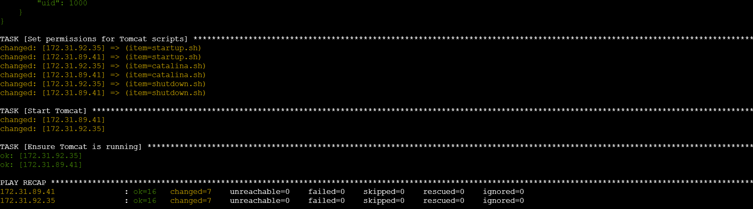

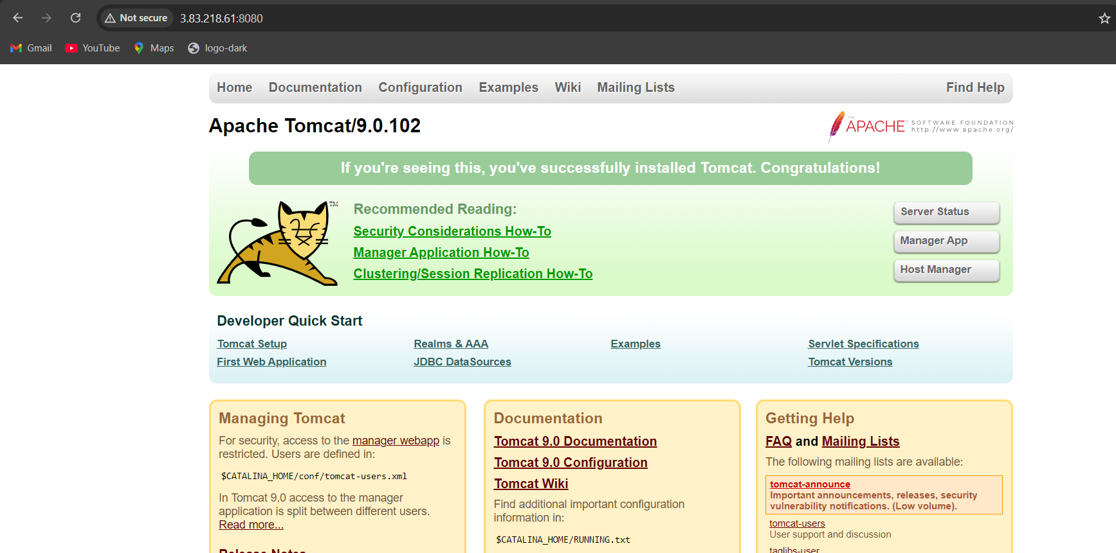

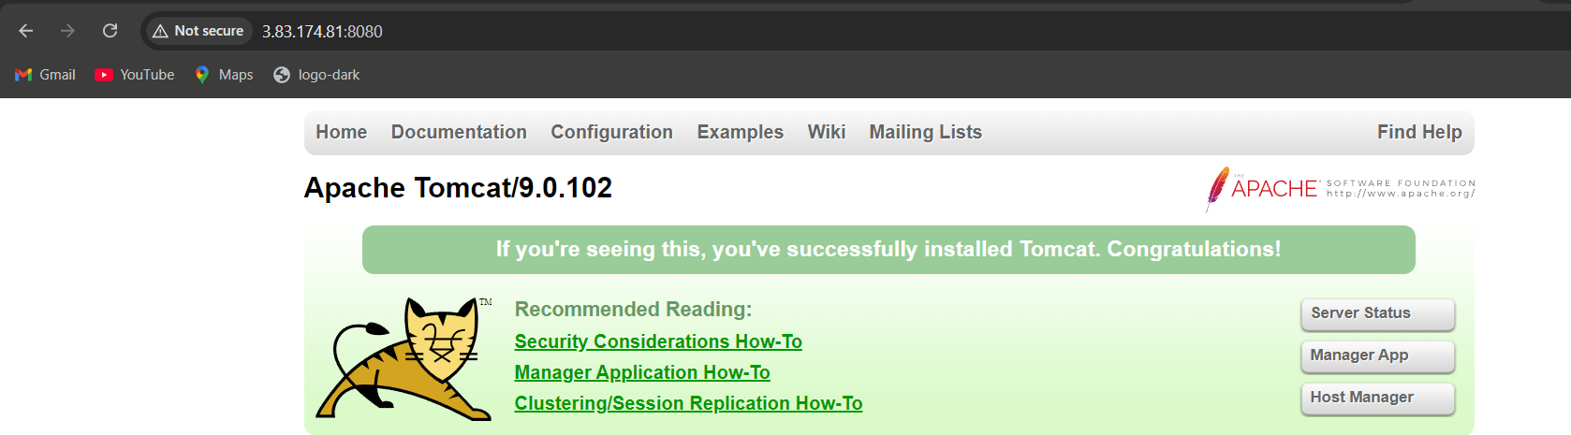

4) Write a ansible playbook to provision one ec2 on aws.

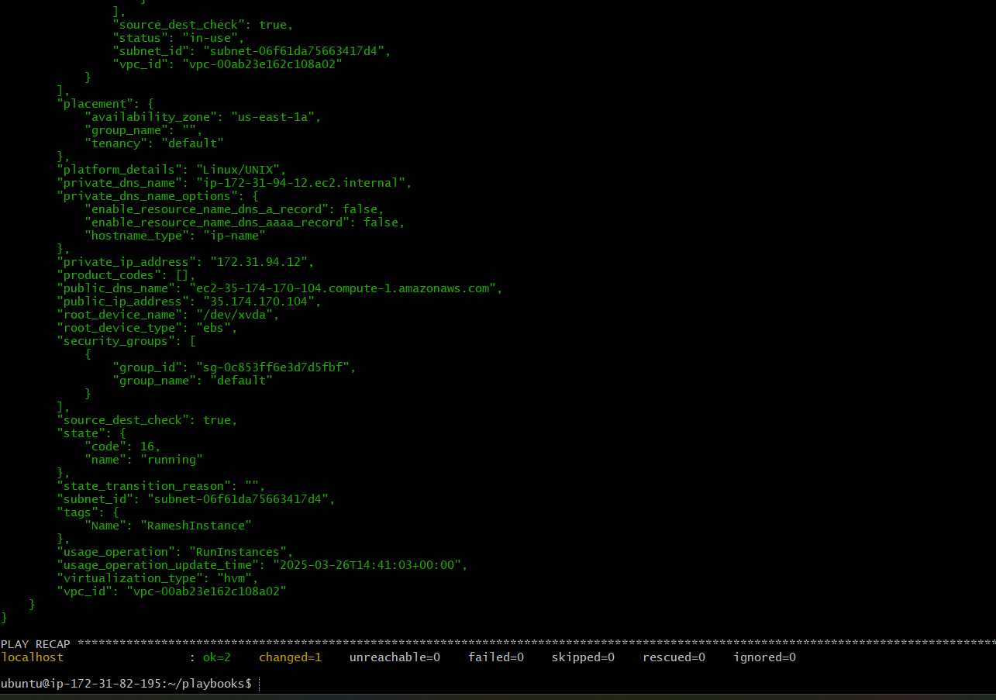

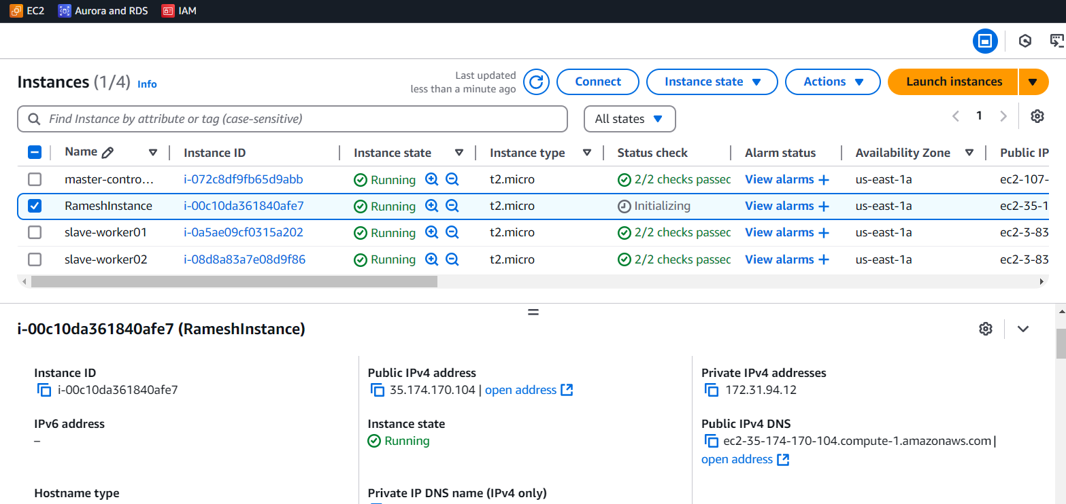

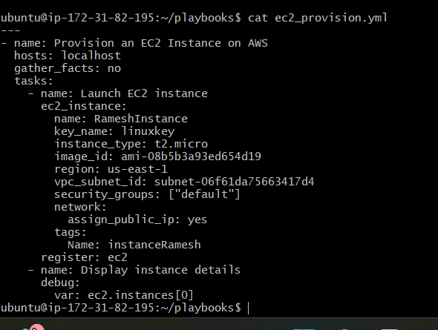

---

- name: Provision an EC2 Instance on AWS

hosts: localhost

gather_facts: no

tasks:

- name: Launch EC2 instance

ec2_instance:

name: RameshInstance

key_name: linuxkey

instance_type: t2.micro

image_id: ami-08b5b3a93ed654d19

region: us-east-1

vpc_subnet_id: subnet-06f61da75663417d4

security_groups: ["default"]

network:

assign_public_ip: yes

tags:

Name: instanceRamesh

register: ec2

- name: Display instance details

debug:

var: ec2.instances[0]

5) Write an ansible playbook to copy one file from node-1 to node-2.

- name: Copy a file from Node-1 to Node-2

hosts: worker-01

gather_facts: no

tasks:

- name: Fetch the file from Node-1 to the control machine

fetch:

src: /tmp/ramesh.txt # Change to the actual file path on Node-1

dest: /tmp/

flat: yes

- name: Transfer the file from the control machine to Node-2

hosts: worker-02

gather_facts: no

tasks:

- name: Copy the file to Node-2

copy:

src: /tmp/ramesh.txt

dest: /tmp # Change to the destination path on Node-2

mode: '0644'

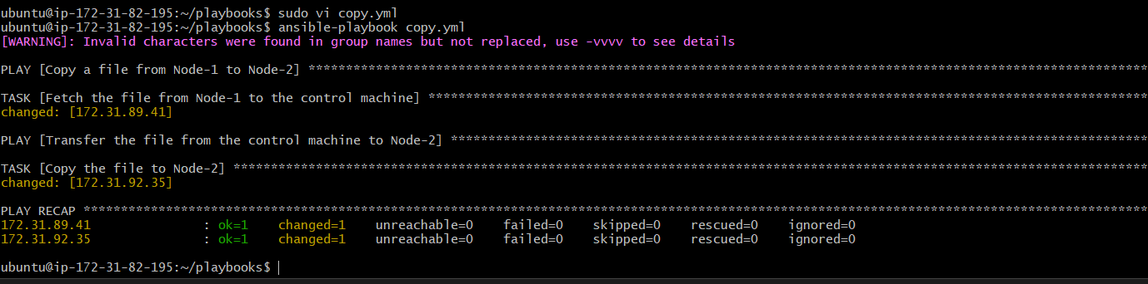

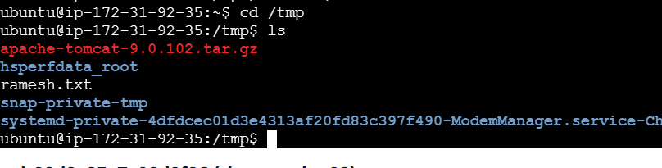

6) Write an ansible playbook to create different files with different names using a single playbook.

- name: Create multiple files with different names

hosts: all

gather_facts: no

tasks:

- name: Create files

file:

path: "/tmp/{{ item }}"

state: touch

mode: '0644'

loop:

- file1.txt

- file2.log

- file3.conf

- file4.json

- file5.yaml

